COGNIFYZ TECHNOLOGIES
DATA SCIENCE INTERNSHIP - LEVEL 1 REPORT
Restaurant Data Exploration, Descriptive Analysis, and Geospatial Analysis Using Python

Submitted By
Yarrabothula Jayanth

Internship Domain
Data Science

Submitted To
Cognifyz Technologies
"Where Data Meets Intelligence"

Tools & Technologies Used
- Python
- Pandas
- NumPy
- Matplotlib
- Scikit-learn
- Visual Studio Code (VS Code)

Submission Date
July 2026

TABLE OF CONTENTS

Section
1. Introduction
2. Objective
3. Dataset Description
4. Tools and Technologies Used
5. Task 1 – Data Exploration and Preprocessing
6. Task 2 – Descriptive Analysis
7. Task 3 – Geospatial Analysis
8. Results and Observations
9. Conclusion

1. Introduction
Data science is the process of collecting, cleaning, analyzing, and interpreting data to uncover meaningful insights that support informed decision-making. Exploratory Data Analysis (EDA) plays a crucial role in understanding the structure, quality, and characteristics of a dataset before applying advanced analytical or machine learning techniques.
This report presents the work completed as part of Level 1 of the Cognifyz Technologies Data Science Internship. The project focuses on analyzing a restaurant dataset using Python to gain insights into restaurant ratings, customer preferences, pricing, cuisines, and geographical distribution. The analysis was performed using widely adopted data science libraries such as Pandas and Matplotlib.
Throughout this level, the dataset was explored, cleaned, summarized, and visualized to identify meaningful patterns and trends. These activities provided hands-on experience with fundamental data science techniques and demonstrated how raw data can be transformed into useful information for business analysis.

2. Objective
The primary objective of this project is to perform exploratory data analysis on a restaurant dataset and extract meaningful insights using Python. This analysis helps in understanding the characteristics of the dataset and identifying patterns that can support data-driven decision-making.
The specific objectives of this project are:
- To explore the structure and characteristics of the restaurant dataset.
- To identify and handle missing values and verify data quality.
- To analyze numerical and categorical features using descriptive statistics.
- To examine the distribution of restaurant ratings and identify any class imbalance.
- To identify the most common cuisines and cities with the highest number of restaurants.
- To analyze the geographical distribution of restaurants using latitude and longitude information.
- To develop practical skills in data preprocessing, exploratory data analysis, and data visualization using Python libraries.

3. Dataset Description
The dataset used in this project contains information about restaurants from multiple cities and countries. It includes both numerical and categorical attributes that describe restaurant characteristics, customer ratings, pricing, and location details.
The dataset consists of 9,551 restaurant records and 21 attributes, providing a comprehensive overview of restaurant-related information.
Some of the important features included in the dataset are:
Feature | Description
Restaurant Name | Name of the restaurant
Country Code | Country identifier
City | City where the restaurant is located
Cuisines | Types of cuisines served
Average Cost for Two | Estimated dining cost for two people
Price Range | Restaurant price category
Aggregate Rating | Overall customer rating
Votes | Number of customer votes
Latitude | Geographic latitude
Longitude | Geographic longitude
Has Table Booking | Availability of table booking
Has Online Delivery | Availability of online delivery

4. Tools and Technologies Used

The following tools and technologies were used to complete the Level 1 tasks of this internship project:

Tool / Technology | Purpose
Python | Core programming language used for data analysis and visualization.
Pandas | Used for loading, cleaning, manipulating, and analyzing the dataset.
NumPy | Supported numerical computations and data processing.
Matplotlib | Used to create charts and visualize the distribution of data.
Scikit-learn | Used in later tasks for machine learning and predictive modeling.
Visual Studio Code (VS Code) | Integrated Development Environment (IDE) used for writing and executing Python programs.
CSV Dataset | Restaurant dataset used for analysis throughout the internship project.
.

Why These Tools?
These technologies were selected because they are widely used in the data science industry. They provide efficient methods for data preprocessing, statistical analysis, visualization, and machine learning, making them suitable for solving real-world analytical problems.

5. Task 1 – Data Exploration and Preprocessing
5.1 Objective
The objective of this task was to understand the structure and quality of the dataset before performing any analysis. This involved examining the dataset, identifying missing values, verifying data types, and studying the distribution of the target variable.

5.2 Methodology
The following steps were carried out during this task:
- Imported the required Python libraries.
- Loaded the restaurant dataset into a Pandas DataFrame.
- Displayed the first few records to understand the data.
- Determined the total number of rows and columns.
- Examined the names and data types of all columns.
- Checked for missing values in each column.
- Verified the overall dataset information using df.info().
- Analyzed the distribution of the Aggregate Rating column using a histogram.
- Examined the target variable for any class imbalance.

5.3 Code Implementation
Note: Insert the important code snippets here (do not include every line of code). For example:
import pandas as pd
df = pd.read_csv("Dataset.csv")
print(df.head())
This code imports the Pandas library, loads the dataset, and displays the first five records to verify that the data has been loaded correctly.
print(df.info())
print(df.isnull().sum())
This code displays the dataset structure and checks for missing values in each column.

5.4 Results
Insert the following screenshots:
- Dataset preview (df.head())
- Dataset information (df.info())
- Missing values output
Label them as:
- Figure 1: Dataset Preview
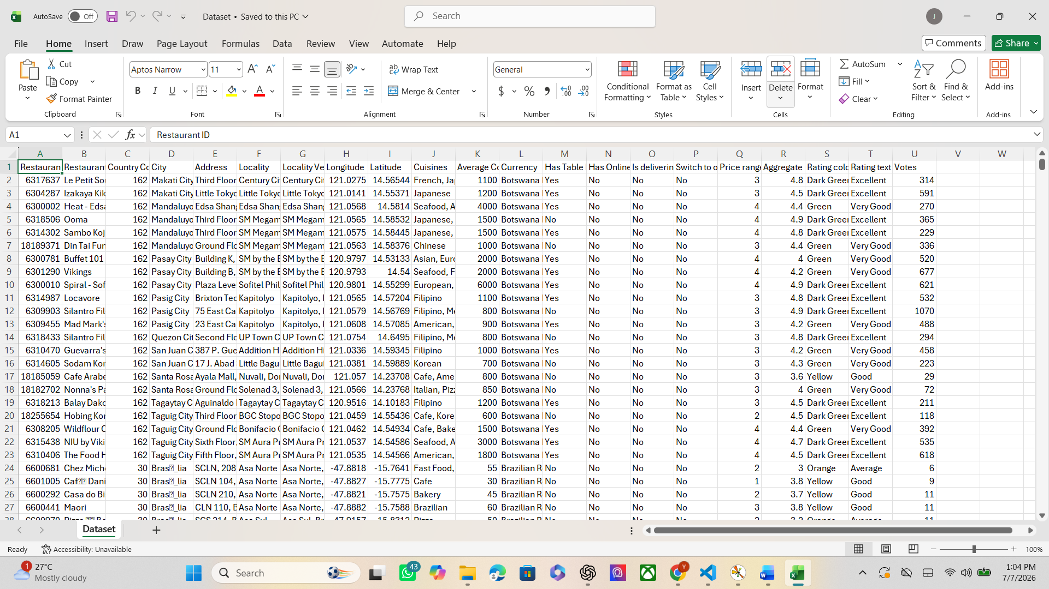
- Figure 2: Dataset Information 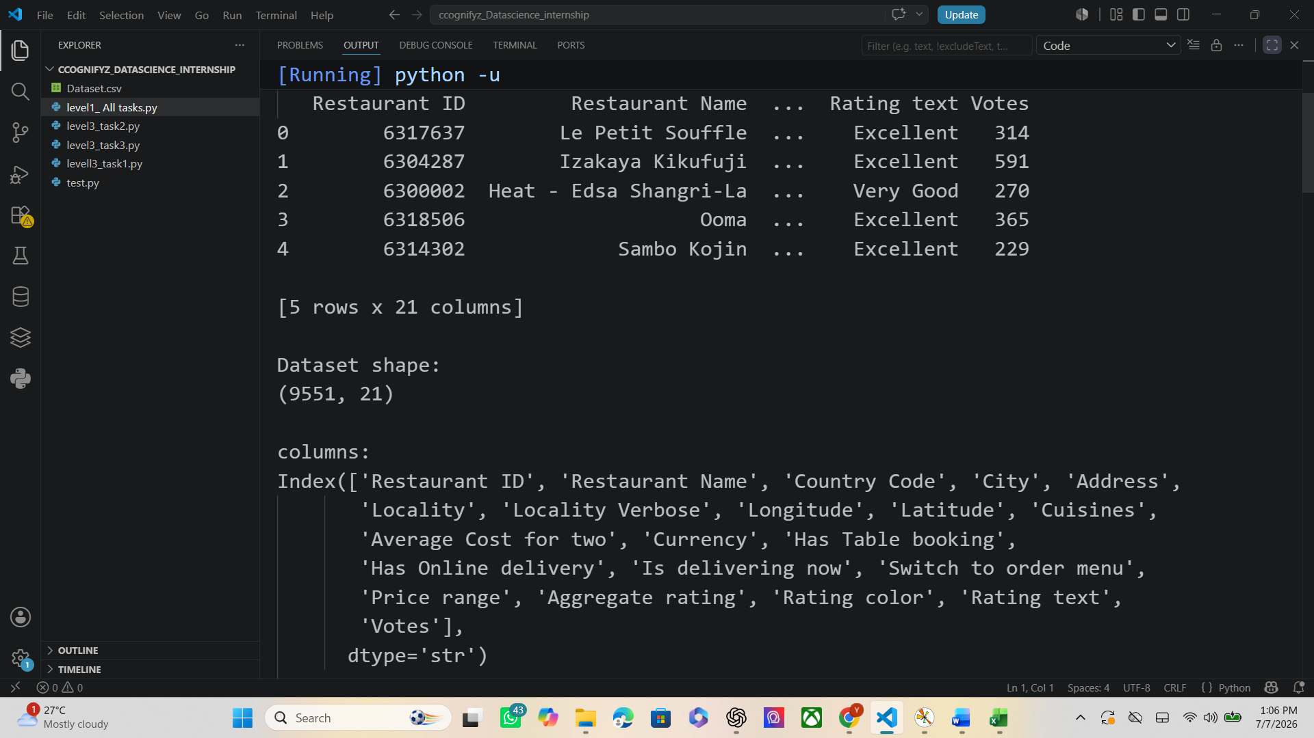

- Figure 3: Missing Values Analysis

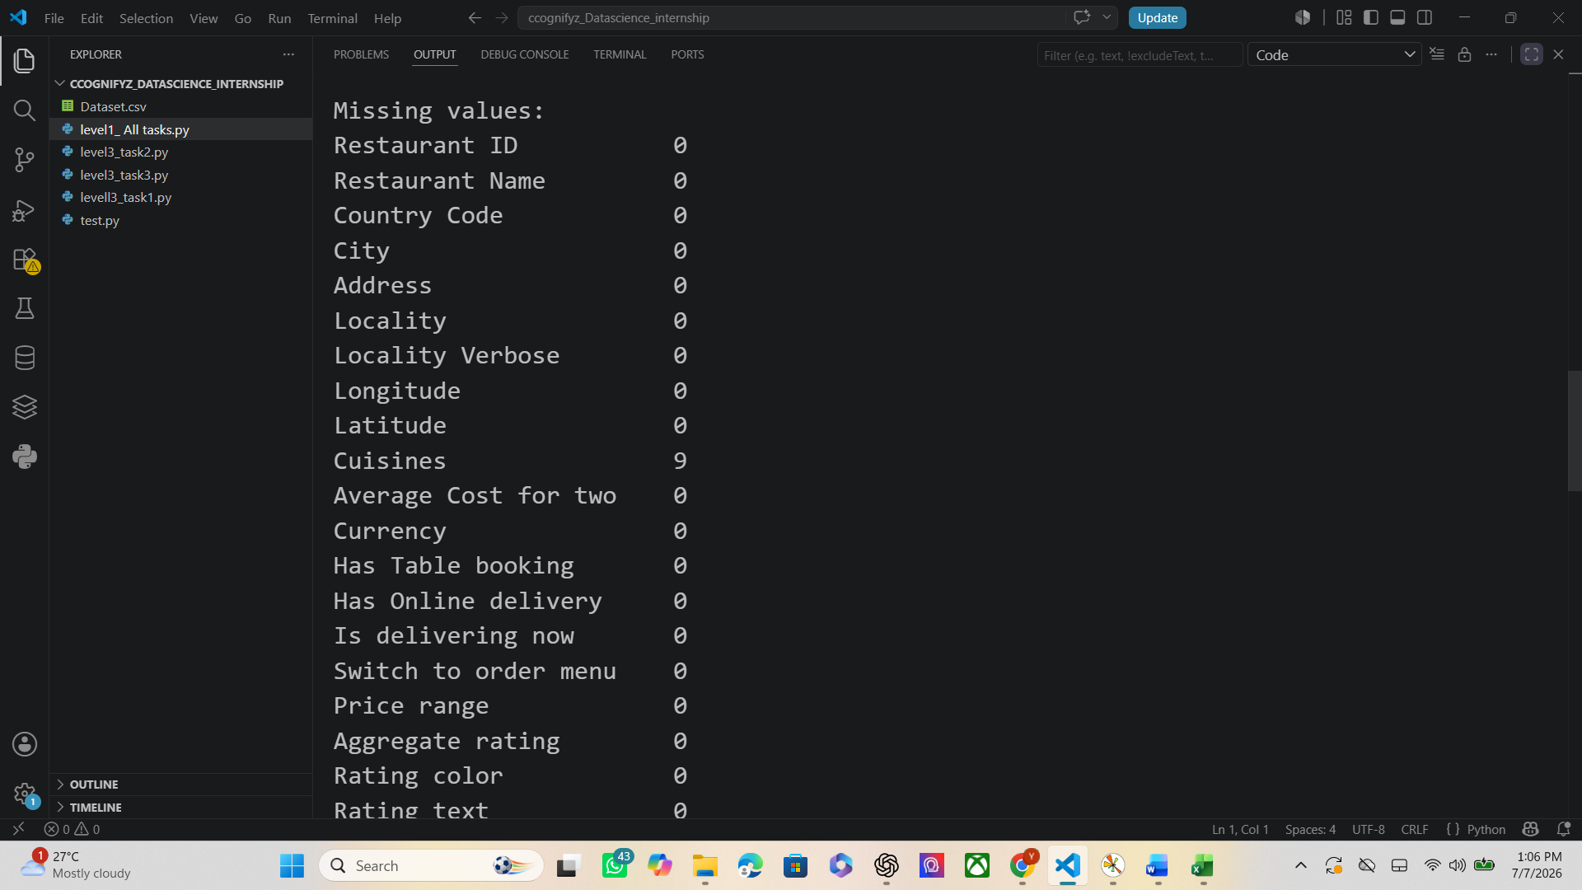
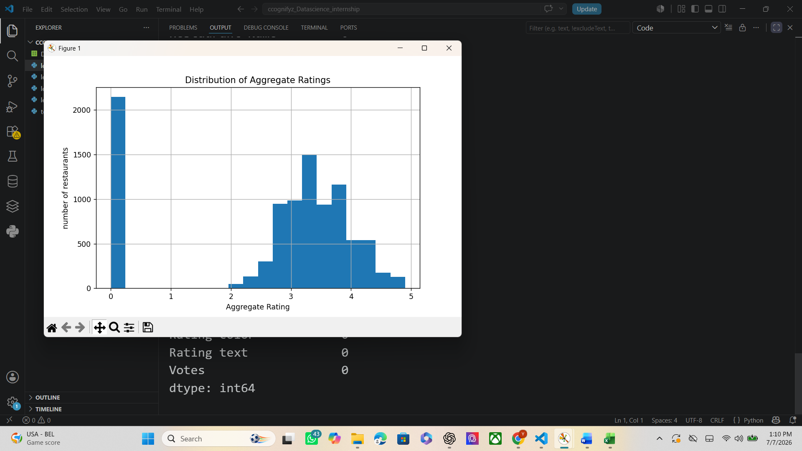
5.5 Observations
The dataset was successfully loaded and inspected. Most columns contained complete information, while a small number of columns had missing values that were identified during preprocessing.
The histogram of Aggregate Rating showed that many restaurants had a rating of 0.0, indicating that they had not yet received customer ratings. Among the rated restaurants, most ratings were concentrated between 3.0 and 4.2, suggesting that the majority of restaurants received positive customer feedback.
The analysis also indicated that the target variable was imbalanced due to the high number of unrated restaurants.

6. Task 2 – Descriptive Analysis
6.1 Objective
The objective of this task was to summarize and analyze the restaurant dataset using descriptive statistics. The analysis focused on understanding the distribution of numerical and categorical variables, identifying the most common cities and cuisines, and discovering meaningful trends within the dataset.

6.2 Methodology
The following steps were performed during this task:
- Generated descriptive statistics for numerical columns using Pandas.
- Calculated statistical measures such as mean, median, minimum, maximum, and standard deviation.
- Examined the distribution of categorical variables, including Country Code, City, and Cuisines.
- Identified the top cities with the highest number of restaurants.
- Determined the most frequently occurring cuisines.
- Created bar charts to visualize the distribution of cities and cuisines.

6.3 Code Implementation
Note: Insert only the important code snippets here, such as:
- df.describe()
- value_counts() for City and Cuisines
- Bar chart generation code
- Insert only the important code:
- df.describe()
Calculates descriptive statistics for numerical columns.

- df["City"].value_counts().head(10)
Identifies the top 10 cities with the highest number of restaurants.

- df["Cuisines"].value_counts().head(10)
Displays the most common cuisines in the dataset.

6.4 Results
Insert the following screenshots:
- Figure 5: Top 10 Cuisines
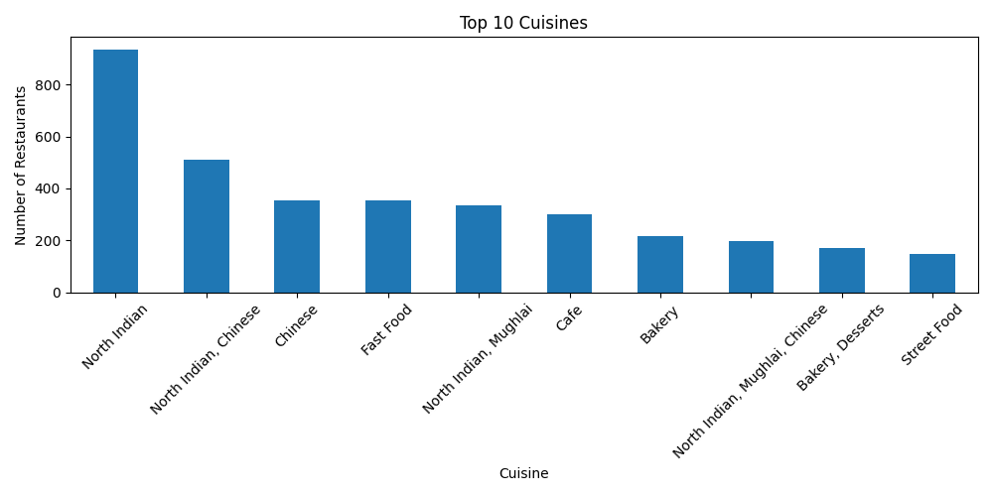
6.5 Observations
The descriptive analysis provided valuable insights into the restaurant dataset.
The statistical summary revealed the overall characteristics of numerical attributes such as customer ratings, average cost for two, price range, and the number of votes received by restaurants.
The city-wise analysis showed that restaurant distribution is concentrated in a limited number of cities, while many other cities have comparatively fewer restaurants.
Similarly, the cuisine analysis indicated that a few cuisine combinations are significantly more common than others, reflecting customer demand and regional food preferences.
The visualizations made it easier to compare restaurant distributions across cities and cuisines and helped identify the most represented categories in the dataset.

6.6 Key Findings
- The dataset contains restaurants from multiple cities and countries.
- A small number of cities account for a large proportion of the restaurants.
- Certain cuisines appear much more frequently than others.
- Descriptive statistics provide a clear overview of pricing, ratings, and customer engagement.

7. Task 3 – Geospatial Analysis
7.1 Objective
The objective of this task was to analyze the geographical distribution of restaurants using their latitude and longitude coordinates. This analysis helps in understanding how restaurants are distributed across different locations and whether geographical factors have any relationship with restaurant ratings.

7.2 Methodology
The following steps were performed during this task:
- Utilized the latitude and longitude attributes available in the dataset.
- Examined the geographical distribution of restaurants across different cities and countries.
- Visualized restaurant locations to understand their spatial distribution.
- Compared restaurant density across various regions.
- Observed whether restaurant ratings showed any noticeable geographical patterns.

7.3 Code Implementation
Note: Include only the important code snippets used for:
- Reading latitude and longitude columns.
- Creating the visualization (or map, if you generated one).
- Any grouping or analysis related to location.
Avoid inserting the complete source code.

7.4 Results
Insert the following screenshots:
- Restaurant Location Analysis
- City-wise Restaurant Distribution
- Geographical Visualization (if applicable)

7.5 Observations
The geographical analysis showed that restaurants are not evenly distributed across all locations. Certain cities contain a significantly higher number of restaurants, indicating greater urban concentration and customer demand.
The latitude and longitude information provides useful spatial context for restaurant locations. While location contributes to restaurant accessibility and customer reach, it does not independently determine customer ratings. Restaurant ratings are also influenced by factors such as food quality, pricing, customer service, and overall dining experience.
Overall, geographical visualization helps identify areas with a high concentration of restaurants and supports location-based business analysis.

8. Overall Results and Discussion
The Level 1 analysis successfully explored and summarized the restaurant dataset using Python-based data analysis techniques.
The preprocessing stage ensured that the dataset structure and quality were understood before analysis. Descriptive statistics highlighted important characteristics of both numerical and categorical variables. Visualization techniques helped identify patterns in restaurant ratings, cuisine preferences, and city-wise restaurant distribution.
The geospatial analysis further enhanced the understanding of restaurant locations by examining their distribution using geographical coordinates.
These analyses demonstrate how exploratory data analysis transforms raw data into meaningful insights that support data-driven decision-making.

9. Conclusion
This project provided practical experience in exploratory data analysis using Python and industry-standard data science libraries.
The restaurant dataset was successfully explored, analyzed, and visualized to gain meaningful insights into customer ratings, restaurant distribution, cuisines, and geographical information.
The knowledge and skills gained through this project strengthened my understanding of data preprocessing, descriptive statistics, visualization techniques, and analytical thinking. These concepts form an important foundation for more advanced data science tasks such as feature engineering, predictive modeling, and machine learning.
Overall, the successful completion of Level 1 enhanced my practical experience in solving real-world data analysis problems and improved my proficiency with Python-based data science tools.

